**Dr. Mark E. Lehr’s**

**Fall 2019**

**Schedule and Office Hours**

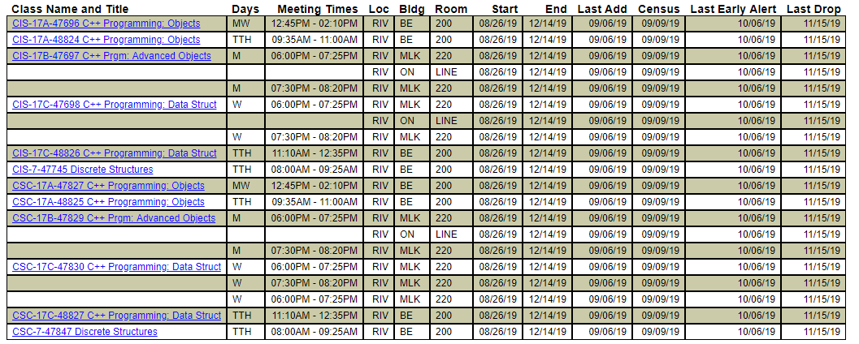

**Office Hours**

**Math/SCI 222 – M 10:30AM to 11:00AM**

**BE 200 – TuThr 7:30AM to 8:00AM**

**BE 200 – TuThr 2:00PM to 2:45PM**

**Math/SCI 222 – W 10:30AM to 12:30AM**

**Other Times Available**

**Lab MLK 220 – M 11:00AM to 12:45AM General Help**

**Lab MLK 220 – MW 05:00PM to 06:00PM General Help**

**Lab MLK 205 – Thur 01:00PM to 2:00PM NASA-Suits and ICPC Programming Competition**