Dr. Mark E. Lehr's
Course Schedule and
Office Hours
Spring 2024

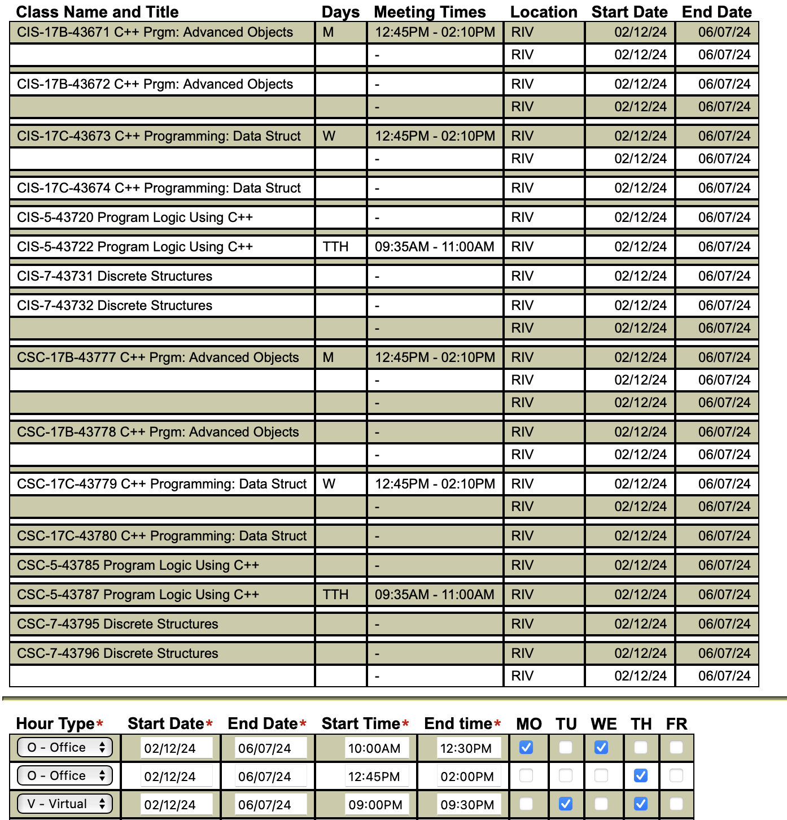
The above Office hours will be held physically in Math/Science 222
and virtually at https://rccd-edu.zoom.us/j/4372081701?pwd=RGsxeFpmY3d2UklzM0Jabm5XVVR4UT09

