Dr. Mark E. Lehrs

Spring 2022 Classes and Office Hours

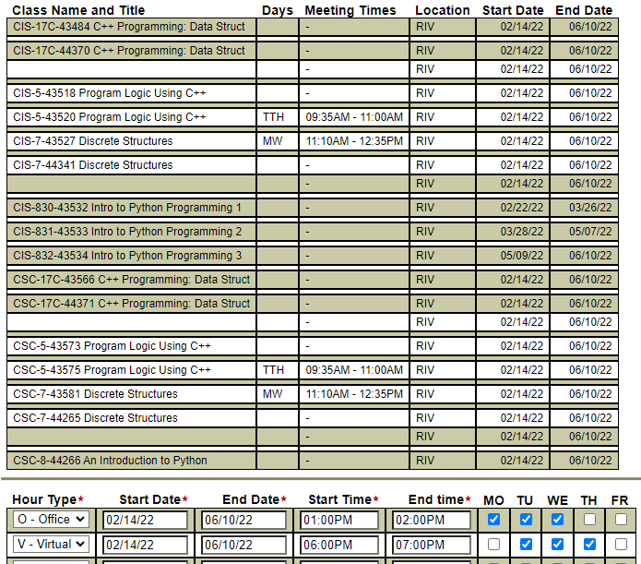

Office Hours – Mon/Tues/Wed in Lab MLK-219 – 1:00PM to 2:00PM

Virtual Hours – Tues/Wed/Thurs in ZOOM 6:00PM to 7:00PM -<https://rccd-edu.zoom.us/j/4372081701?pwd=RGsxeFpmY3d2UklzM0Jabm5XVVR4UT09>