**How to install NetBeans on Mac**

Version 0.5 (Jan 5, 2021)

The following should work on macOS versions 10.15 (Catalina) or 11 (Big Sur). You can check your OS version by clicking the Apple icon in the upper left corner of the screen (), then clicking ‘**About this Mac**’.

For CIS/CSC-5, we suggest installing NetBeans version 12 or above, as described below. However, version 8.2 is sufficient for this course, if the following does not work.

1. 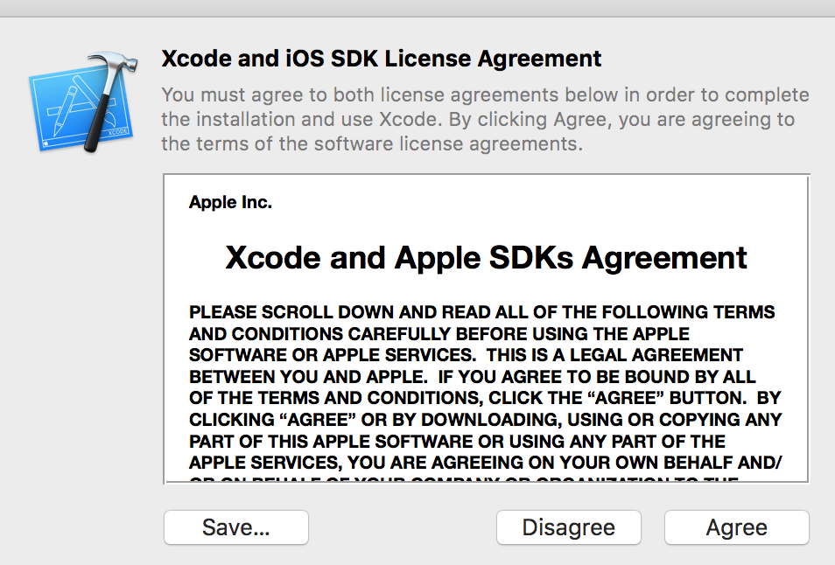**Install Xcode[1]**   
   To compile C/C++ code, you need to install a compiler. **Xcode** is a set of programming tools, compilers, and IDE that works natively on the Mac platform. It includes a C/C++ compiler.  
     
   Search for ‘**xcode**’ in the **App Store** and install it.  
   It is fairly large, so it may take some time to install.  
     
   After **Xcode** is installed, open it. If you see a window about a license agreement, make sure to click ‘Agree’:  
   Once you see the ‘**Welcome to Xcode**’ splash screen, you can close **Xcode** (click the ‘**Xcod**e’ menu, then ‘**Quit Xcode**’).
2. **A picture containing icon

   Description automatically generatedDownload NetBeans**Open the page: <https://netbeans.apache.org/download/index.html>   
   in a web browser and select a version of NetBeans to download.  
   NetBeans 12 or 12.2 are the suggested versions:  
     
   Make sure to select the appropriate file to download for Mac. The file name should end with ‘**.dmg**’.

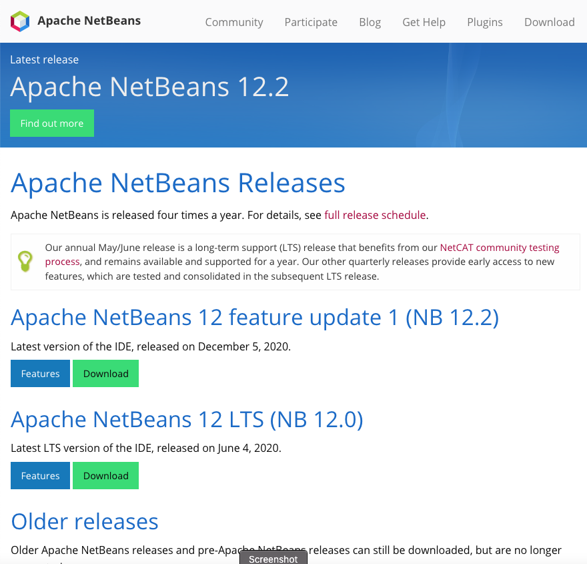

1. **Install NetBeans**  
   The downloaded NetBeans file should be in your Downloads folder. Open a finder window and navigate to Downloads.  
   Double-click on the file to install it.  
   Graphical user interface, text, application, email

   Description automatically generated
2. **Configure NetBeans for C/C++**By default, NetBeans is not able to work with C/C++ projects. A plugin needs to be installed to enable it to work with the C/C++ tools available from XCode.  
     
   Open NetBeans and go to the ‘**Tools**’ menu, then select ‘**Plugins**’. In the Plugins window, click the ‘**Settings**’ tab. Activate the ‘**NetBeans 8.2 Plugin Portal**’ by checking the box next to it.  
   Graphical user interface, text, application

   Description automatically generated  
   Now go to the ‘**Available Plugins**’ tab in the Plugins window. If there is an entry for ‘**C/C++**’, check the box next to it and install it. Make sure it installs successfully. If it fails, it might be that the version of the Java JDK on your system is not compatible with NetBeans. See the **Troubleshooting** section (below) for possible fixes.  
     
   Close the **Plugins** window.



1. A picture containing shape

   Description automatically generatedGraphical user interface, text, application

   Description automatically generated**Test NetBeans**Several things can go wrong when installing and configuring NetBeans, so it is necessary to check that it is working properly.  
     
   Open NetBeans and click on the ‘**New Project’** icon in the upper left corner of the NetBeans window ( ). An alternative way to open a new project is to click the ‘**File**’ menu, then ‘**New Project…**’, The New Project window should pop up. Check that ‘**C/C++**’ appears as an option in the ‘Categories’ list:



If you ***do not*** see a ‘**C/C++**’ entry in the **Categories** list, or you see it, but the only type listed in the **Projects** list is ‘**Lightweight C/C++ Project**’, try the following:

* 1. Check that the ‘**NetBeans 8.2 Plugin Portal**’ has been checked in **Tools**->**Plugins**->**Settings**, as described in Step 4.
  2. In **Tools**->**Plugins**->**Available Plugins**, *if there is a ‘****C/C++****’ entry*, make sure it is checked/activated, also as described in Step 4.  
       
     If you do check/activate the ‘**C/C++**’ entry, ***make sure it says it installed successfully***. If an error is reported instead, there could be a conflict with the installed version of Java – see   
     the Troubleshooting section below on what to do next.
  3. Restart NetBeans.
  4. If ‘**C/C++**’ still does not appear in the **New Project** window, check the Troubleshooting section below for possible solutions.  
     A likely issue can be an installed Java version that does not work with this NetBeans version.

If ‘**C/C++**’ is in the **Categories** list, create a simple ‘hello world’ program to test NetBeans.



Ask a CIS/CSC lab aide or your instructor if you need help doing this.

**Troubleshooting**

* A picture containing monitor, image, close

  Description automatically generated**If Xcode won’t install or takes up too much disk space…**You may be able to install *just* the C++ compiler and not all of **Xcode**.  
  Open a terminal window (**Go** menu -> **Utilities** -> **Terminal**).  
  Type ‘**g++**‘ and press **<return>**. If a window pops up asking if you want to install the command line developer tools, click ‘**Install**’.
* **If NetBeans installed, but you can’t create a C/C++ project…**
  + A picture containing monitor, image, close

    Description automatically generatedText

    Description automatically generated**Check if a C/C++ compiler is installed on your computer.**If you haven’t already, try installing **Xcode**, as described in Step 1. ***Make sure to run Xcode after installation and ‘agree’ to any license agreement that pops up.***  
    You can check if the compiler is installed by opening a terminal window  
     (**Go** menu -> **Utilities** -> **Terminal**).  
    In the terminal window, type ‘**g++ --version**’ and press **<return>**. If information about the C++ compiler appears in the window, the compiler ***is*** installed.  
    However, if the returned message says something like ‘**No such file or directory**’, the compiler is not installed, or is not configured correctly. You might try reinstalling **Xcode**, if this is the case.  
    You may also try ‘**c++ --version**’ or ‘**clang --version**’ in the Terminal window, as these are other names for the compiler.
  + **Check that the NetBeans 8.2 plugin is installed**.  
    Follow the instructions in Step 4.
  + **There might be a conflict with the Java version and NetBeans.**NetBeans 12 may not work with Java 14 or above. See <https://stackoverflow.com/questions/63954870/does-apache-netbeans-12-1-support-jdk-15>. If this is the configuration on your computer, it may be possible to install an older version of Java and instruct NetBeans to use this version.  
    Details on how to do this are somewhat technical. Ask a CIS/CSC lab aide for assistance on this.

1. Although this is our current standard way of getting a C++ compiler on Mac, there may be an alternative method that does not require installing all of **Xcode**. See the section under **Troubleshooting** called ‘**If Xcode won’t install or takes up too much disk space…**’.