How to download NetBeans 8.2 (Note: don’t run NetBeans 8.2 installer before installing Java version 8 JDK and/or Cygwin)
- Download java version 8 jdk (I drew a box around the 64-bit version because it is the one that will most likely be)
  - Link: https://www.oracle.com/java/technologies/javase-jdk8-downloads.html
    - You can search java version 8 jdk if link does not work
  - Image (scroll down the page to reach spot): 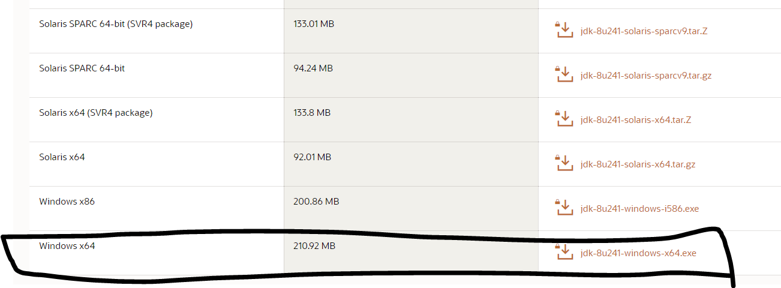
  - Follow installation steps and leave default setting from installer as they are
- Download Cygwin (64-bit version) and run executable
  - Link: https://www.cygwin.com/
  - Image (scroll down the page to reach spot): 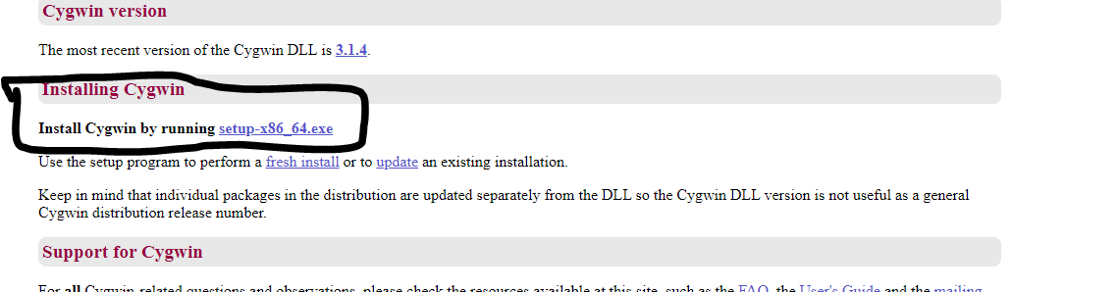
- Run Cygwin setup-x86_64.exe and press next for the next few steps until you reach list of packages. leave default setting from installer

  - 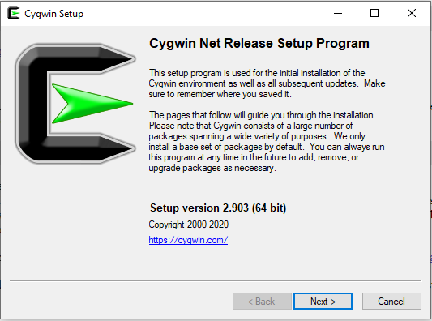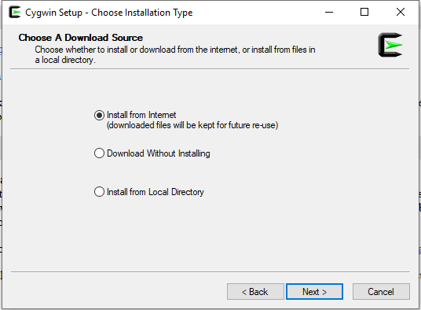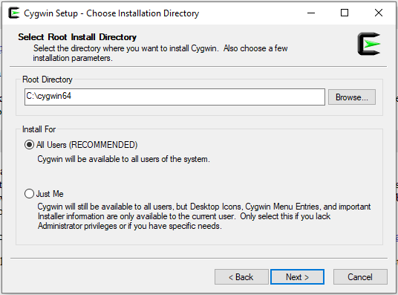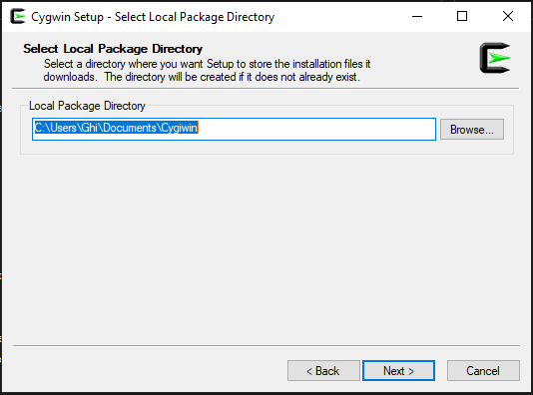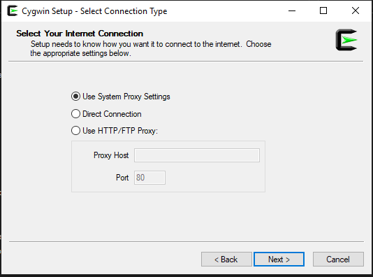
  - Choose any mirror links, it does not matter
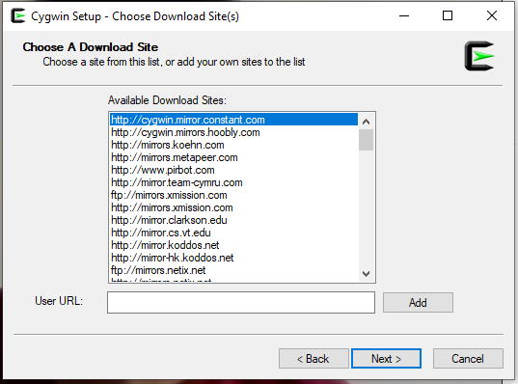

- Currently the page should be list of packages. Make sure that from the top left drop-down menu for view that full is selected
  - In the search box enter gcc. From the package column find gcc-core and gcc-g++. For each package under the column New, click the drop-down arrow button and select the highest non-test version in the list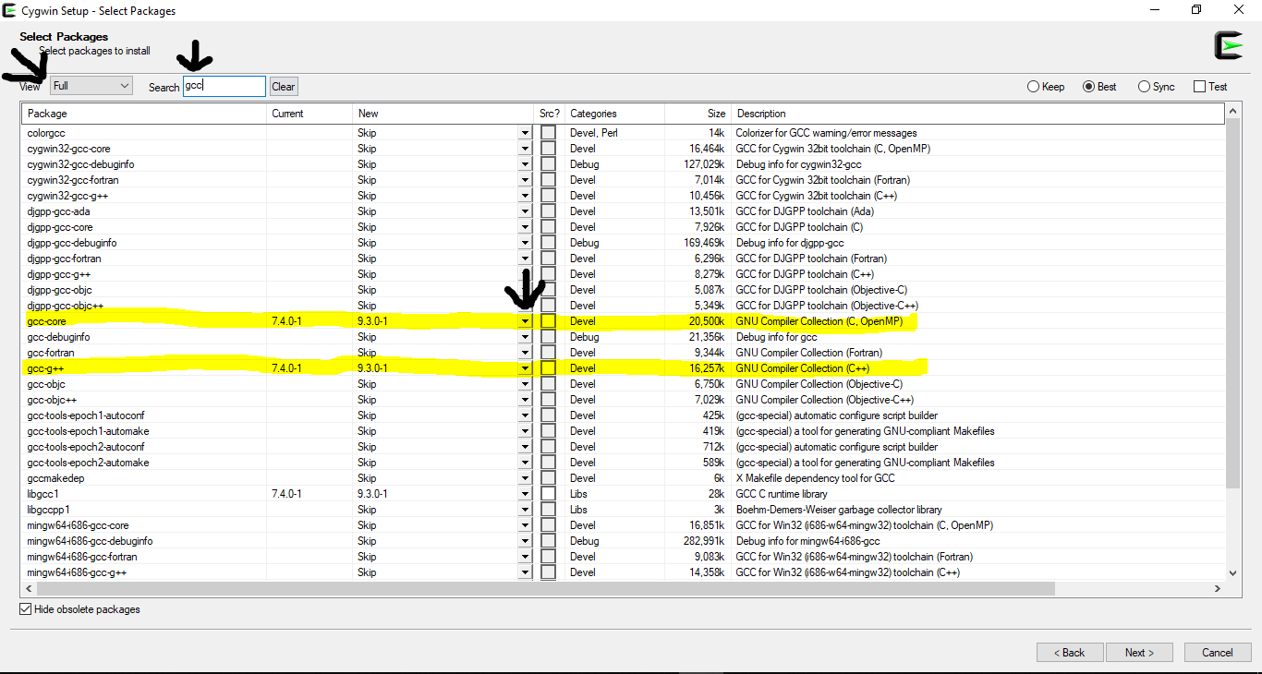
  - In the search box enter gdb and find package name gdb and select highest non-test version under column New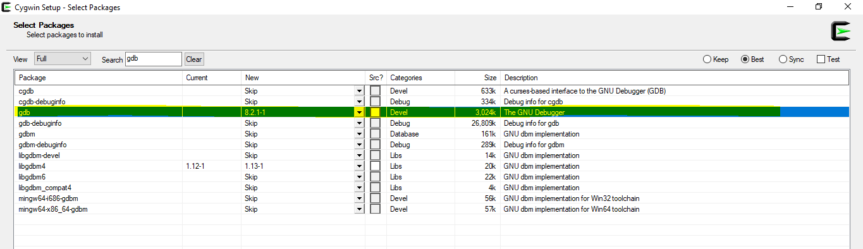
  - In the search box enter make and find package make and under the column New select highest non-test version
  - 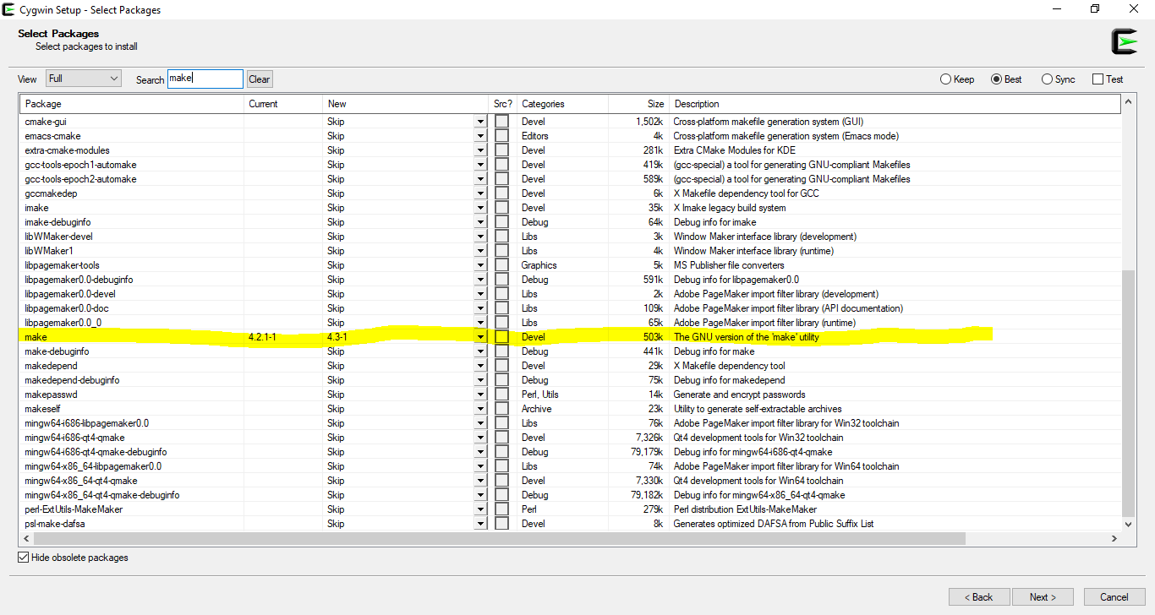Click next after selecting all 4 packages, next page should be a list of packages that will be installing (Mine is different because some of those packages are already installed). After seeing the list click next and download should start. Next step will take a while 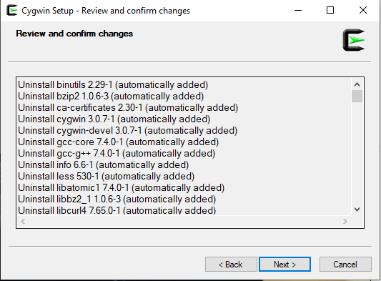
  - After installation is complete, click finish or done to exit installer
- Download NetBeans 8.2
  - Link: https://netbeans.org/downloads/8.2/rc/ (Link should work, if not search “Download NetBeans 8.2)
  - Select download link under All column (This option I think is less likely to have problems)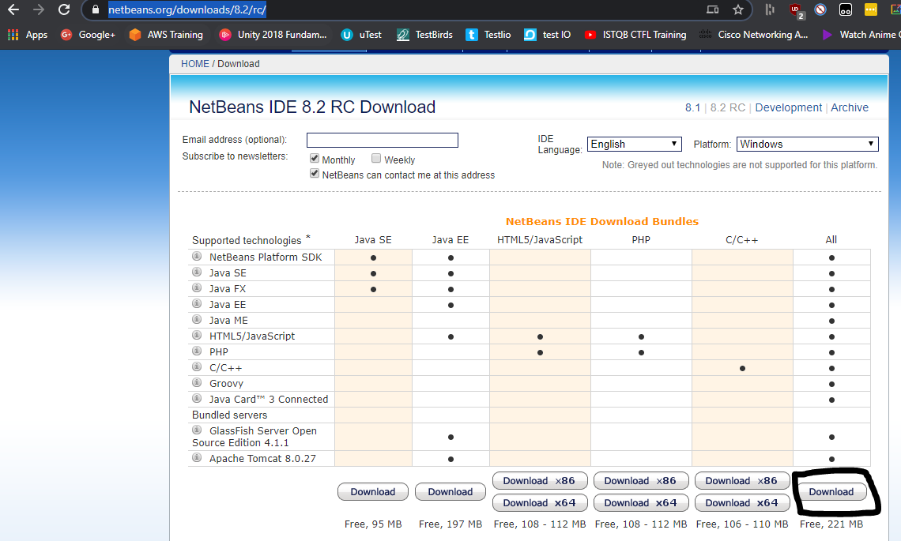
  - Run NetBeans installer and follow the steps without changing any of the default setting by clicking next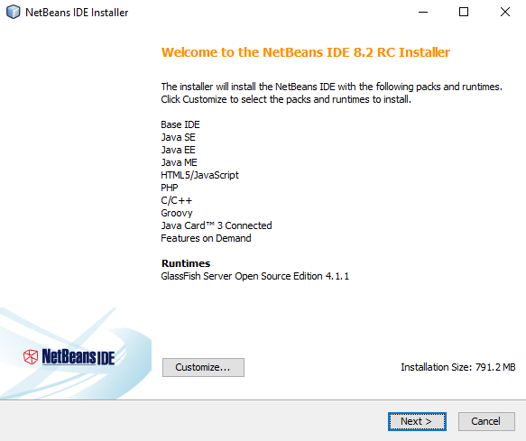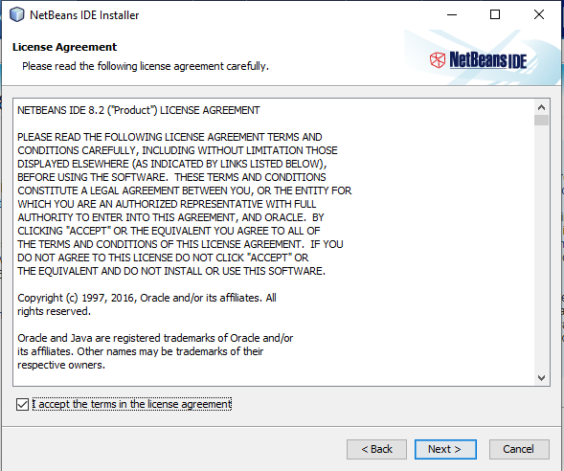
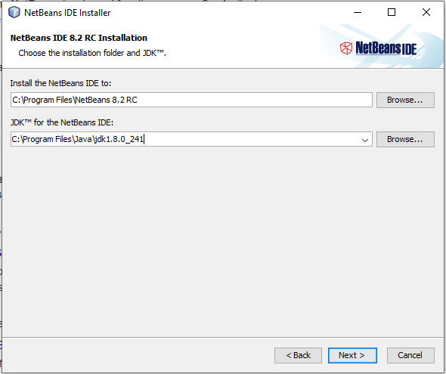
Figure 1d. Make sure that under JDK for the NetBeans IDE to select Java version 8 from drop down menu

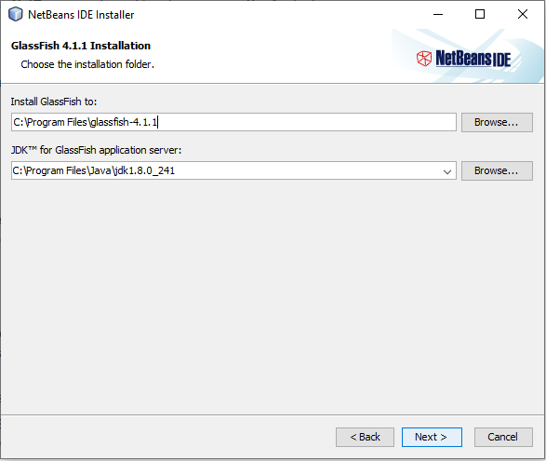
Make sure that under JDK for the NetBeans IDE to select Java version 8 from drop down menu
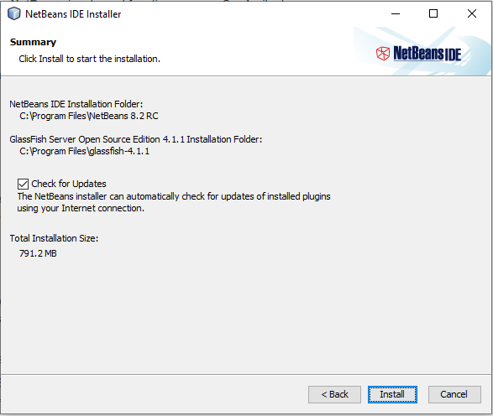
Figure 2 Click install
(Installation should take a while. After its done click finish or done, run and test NetBeans to see if it run)

